
Holy Cross College

Semester 1 Examination 2019

Question/Answer Booklet

Please place your student identification label in this box
Year 10 Science
(Adjusted)

Student Name
Student’s Teacher

Time allowed for this paper

Reading time before commencing work: 5 minutes
Working time for paper: 60 minutes

Materials required/recommended for this paper

To be provided by the supervisor

This Question/Answer Booklet
Data Sheet

To be provided by the candidate

Standard items: pens, pencils, eraser, correction fluid, ruler, highlighters.
Special items: non-programmable calculators satisfying the conditions set by the School Curriculum and Standards Authority for this course.

Important note to candidates

No other items may be taken into the examination room. It is your responsibility to ensure that you do not have any unauthorised notes or other items of a non-personal nature in the examination room. If you have any unauthorised material with you, hand it to the supervisor before reading any further.

Structure of this paper

Section | Number of questions available | Number of questions to be answered | Suggested working time  (minutes) | Marks available | Percentage of exam
Section One:  Multiple Choice | 20 | 20 | 15 | 20 | 26
Section Two:  Short Answer | 16 | 16 | 45 | 58 | 74
Section Three:
Comprehension
 |  |  |  | 78 | 100

Instructions to candidates

1. The rules for the conduct of examinations at Holy Cross College are detailed in the College Examination Policy. Sitting this examination implies that you agree to abide by these rules.

2. Write your answers in this Question/Answer Booklet.

3. Working or reasoning should be clearly shown when calculating or estimating answers.

4. You must be careful to confine your responses to the specific questions asked and to follow any instructions that are specific to a particular question.

5. Spare pages are included at the end of this booklet. They can be used for planning your responses and/or as additional space if required to continue an answer.

• Planning: If you use the spare pages for planning, indicate this clearly at the top of the page.
• Continuing an answer: If you need to use the space to continue an answer, indicate in the original answer space where the answer is continued, i.e. give the page number.
• Fill in the number of the question(s) that you are continuing to answer at the top of the page.

SECTION 1 MULTIPLE CHOICE (20 marks)

Choose the best answer for each question in the Multiple Choice Question booklet.

Mark your selection with a cross.

1 | (a) | (b) | (c) | (d)
2 | (a) | (b) | (c) | (d)
3 | (a) | (b) | (c) | (d)
4 | (a) | (b) | (c) | (d)
5 | (a) | (b) | (c) | (d)
6 | (a) | (b) | (c) | (d)
7 | (a) | (b) | (c) | (d)
8 | (a) | (b) | (c) | (d)
9 | (a) | (b) | (c) | (d)
10 | (a) | (b) | (c) | (d)
11 | (a) | (b) | (c) | (d)
12 | (a) | (b) | (c) | (d)
13 | (a) | (b) | (c) | (d)
14 | (a) | (b) | (c) | (d)
15 | (a) | (b) | (c) | (d)
16 | (a) | (b) | (c) | (d)
17 | (a) | (b) | (c) | (d)
18 | (a) | (b) | (c) | (d)
19 | (a) | (b) | (c) | (d)
20 | (a) | (b) | (c) | (d)

SECTION 2 SHORT ANSWER (58 marks)

Attempt all questions. Write your answers in the spaces provided.

1. Use the words listed below to complete the following sentences. (7 marks)

protostar | billion | nebulae | giants | fusion
space | expansion

Clouds of dust and gas in interstellar space are called .

According to the Big Bang Theory, the universe is about 13.7 years old.

The first stage of the Big Bang involved the formation of time and .

Space then underwent rapid .

Stars are formed when gravity causes gas and dust to come together and heat up.

Eventually a is formed and then finally a star.

Stars like our sun evolve into red before they explode.

Stars generate their energy by nuclear in which hydrogen changes to helium.

2. What does the Big Bang Theory state? (2 marks)

3. Arrange the following stages in the life cycle of a star in the correct order from earliest to latest.

red giant, white dwarf, main sequence star, black dwarf
(2 marks)

4. A racing car makes a ‘yeee … owww’ sound as it speeds towards and then past an observer.

Choose the correct terms in the following statement, relating the sound to the blue and red shift of the Doppler effect and to the movement of galaxies towards and away from us. (Circle the correct answer.) (3 marks)
The ‘yeee’ is a higher / lower frequency, which corresponds to a

blue shift / red shift in light, which indicates movement towards / away

from us.

5. Complete the following table. Include the correct units. (Hint: Use sp, d, t triangle.)
(3 marks)

Distance travelled | Time taken | Average speed
200 m |  | 8 m/s
 | 25 s | 15 m/s
2750 m | 132 s

6. How long will it take to complete a trip by car from Perth to Kalgoorlie, a distance of 595 km, travelling at an average speed of 85 km/h? (Give your answer in hours.) (Hint: Use sp, d, t triangle.) (3 marks)

7. Tim and Peter are good friends who live in the Rivervale area. Tim was planning to walk from his place to Peter's and the map below shows their respective houses. Use the map to do the following.

(a) Trace on the map the way you would walk to Peter's house. Using the scale, calculate (approximately) the distance you would walk. (2 marks)

(b) Use the scale to determine the displacement and bearing from Tim's house to Peter's house. Remember to draw the compass directions on the map.
(3 marks)

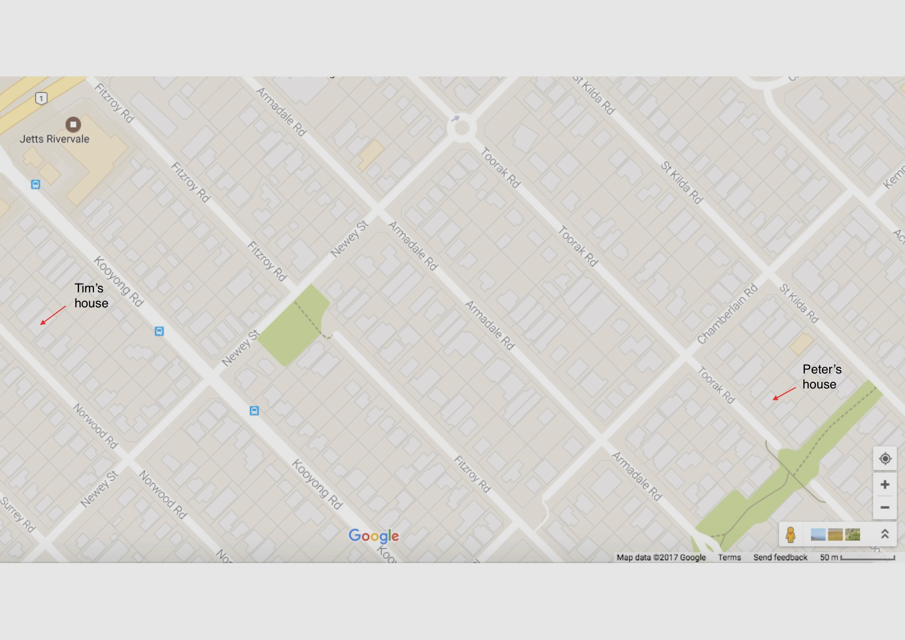
8. Use the periodic table supplied to classify each of the elements below as either metals, non-metals or metalloids. (5 marks)

Mg, C, As, Kr, Fe, N, H, Al, Cu, B

Metal | Non-metal | Metalloid

9. Complete the following table showing the number of particles of each element.
(7 marks)

Element Name | Element symbol | Atomic number | Mass number | Number of Protons | Number of Neutrons | Number of Electrons
Carbon |  |  | 12
Calcium |  | 20 |  |  | 20
 | H | 1 | 2
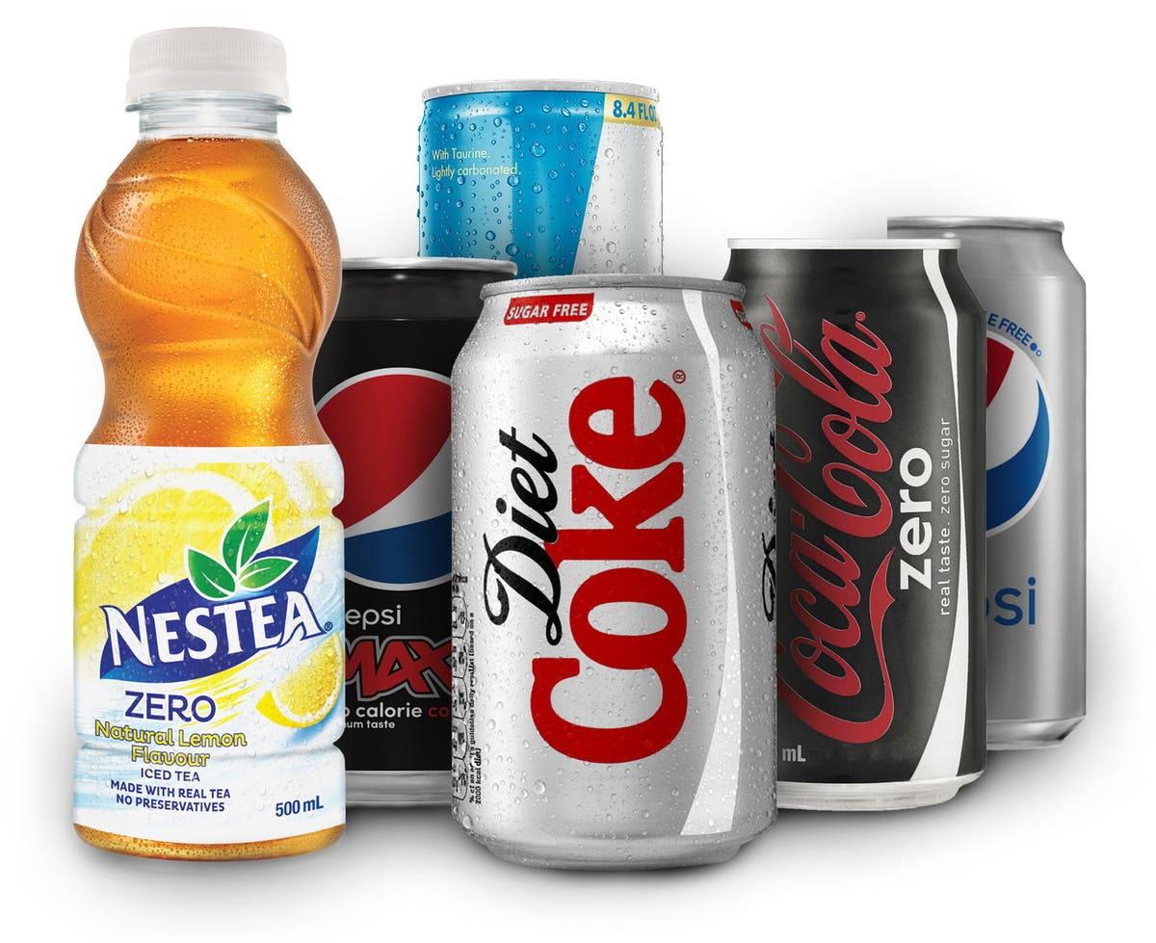

10. Aluminium is used to make soft drink cans.

(a) Is aluminium a pure substance or a mixture? (1 mark)

(b) Circle the type of bonding in aluminium. (1 mark)

metallic covalent ionic

(c) One property that makes aluminium suitable to make soft drink cans is its malleability.

(i) Define malleability. (1 mark)

(ii) Explain why it is important for aluminium to be malleable if it is to be used in the production of cans. (1 mark)

(iii) Describe one disadvantage of aluminium being malleable. (1 mark)

11. Describe three features of DNA structure (shape, what it is made of, etc.) (3 marks)

•

•

•

12. Complete the complementary DNA strand for the sequence below. (1 mark)

T A C G G A C T T G C A

13. Label the following stages of the cell cycle and mitosis using the words listed.
(5 marks)
metaphase, telophase, anaphase, interphase, prophase
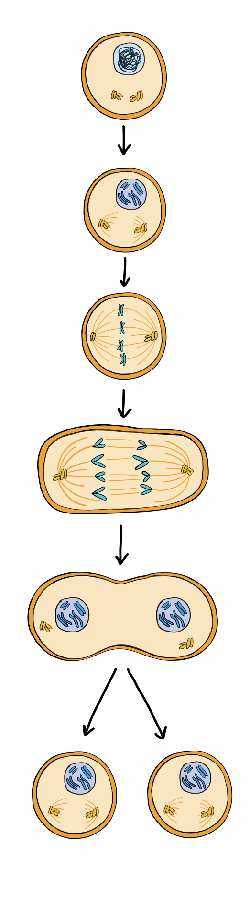





14. Describe the role of the spindle fibres in mitosis. (1 mark)

15. Brown eyes are dominant to blue eyes.

(a) A blue-eyed woman marries a man with brown eyes. Their first child has blue eyes. What does this tell us about the father’s genotype? (1 mark)

(b) What chance does their second child have of inheriting brown eyes? Use a Punnett square to show your working. (2 marks)

16. (a) A red flower (RR) and a white flower (WW) are crossed to produce a pink flower. What is the name of this type of inheritance? (1 mark)

(b) Two pink flowers are mixed. Complete a Punnett square to show the possible offspring. (2 marks)

END OF EXAMINATION
ADDITIONAL WORKING SPACE

